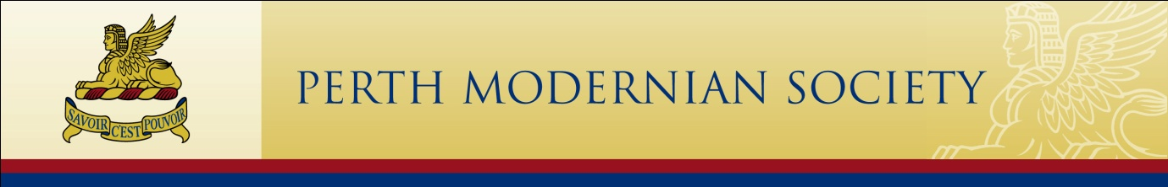

The Perth Modernian Awards

Under its constitution, the Perth Modernian Society Council is empowered to recognise those who give “distinguished service to Perth Modern School, the Society, the Sphinx Foundation, or the public, or any section of it.”

Inaugurated in 2014, the Perth Modernian Awards will be a most appropriate way to honour people who have made a significant contribution to advance the primary object of the Perth Modernian Society (Inc.), namely the advancement of education for the benefit of the community as a whole, but with particular reference to Perth Modern School.

The Perth Modernian Awards are intended to recognise the actions and achievements of people who have gone above and beyond what could be reasonably expected, to advance education through the Perth Modernian Society (Inc.).

Any member of the Perth Modernian Society can nominate an individual for an award, and the nominees can be Perth Modernians, persons eligible to be Perth Modernians, or members of the wider community.

Initially preference shall be given to living persons.

The Perth Modernian Society will make awards under three separate categories.

- Modernian Fellow
Modernian Fellow is the highest award made to a limited number of members of the Perth Modernian Society or those who qualify to be a member, for distinguished service to the advancement of education at Perth Modern School.

- Moderna Scola Award
The Moderna Scola Award is made to members of the Perth Modernian Society or those who qualify to be a member, for significant service to the advancement of education at Perth Modern School.

- Honorary Member of the Perth Modernian Society
Honorary Membership of the Perth Modernian Society is awarded in recognition of distinguished service to the advancement of education at Perth Modern School, to an individual not eligible for Society Membership;

The Perth Modernian Awards - Information Sheet

Who can be nominated?
Any person can be nominated for an award within the Perth Modernian Honours Scheme.
Any member of the Perth Modernian Society can nominate someone for an award.

How are nominations assessed?
At its first meeting following each Annual General Meeting, the Council will establish a three-member Standing Awards Committee. Not all members of the Standing Awards Committee need be current members of Council although they must be members of the Society.

The Awards Committee may meet with the nominators and any other relevant individuals and consider all available evidence before making recommendations to the Council.

If not less than two thirds of the Council’s members present and voting, accept the Committee’s recommendation, a letter will be sent to the nominee asking if they agree to accept the recognition which will be awarded at the next significant function, usually the AGM or the Annual Reunion.

Is it necessary to provide referees?
The Council will make its decisions based on all available information. While it is not essential that you submit the names of referees, the more information you include, the better.

Are nominations confidential?
All nominations are strictly confidential and the information provided will be used only to assist the Council in making its decision. The person nominated should not be advised of his or her nomination.

How long will it take for decisions to be made?
The Standing Awards Committee will proceed as quickly as possible to make its recommendations.

How are recipients told of their awards?
Once the Council has accepted the recommendation of the Standing Awards Committee, the President will write to the proposed recipient to ascertain whether or not he or she agrees to accept.

Are nominators advised?
If a nomination is unsuccessful, the nominator will be notified following the relevant Council decision. If a nomination is successful, the nominator will be notified soon after the nominee agrees to accept the award.

More information or help
Any member of the Perth Modernian Society Council is happy to provide further information or contact the Awards Committee by email or surface mail.

Email (in confidence) to: awards@perthmoderniansociety.org.au

Or mail your questions to:
Awards Committee
Perth Modernian Society (Inc.),
c/o Perth Modern School,
90 Roberts Road, Subiaco, WA 6008 AUSTRALIA

The Perth Modernian Awards

NOMINATION FORM

CONTACT DETAILS FOR THE PERSON SUBMITTING THE NOMINATION

Title (Ms, Mr, Mrs, Dr, etc)

Surname

Given names

Postal address | Post Code
Email address

Phone | Home Work  Mobile
Are you a member of the Perth Modernian Society?

How do you know the person you are nominating?

Signature

Date | / /

DETAILS OF THE NOMINEE

Note: Nominations are confidential. Please DO NOT tell the person that he or she is being nominated.

Title (Ms, Mr, Mrs, Dr, etc)

Surname

Given names

Postal address | Post Code
Email address

Phone | Home Work  Mobile
Was the nominee a student or member of staff at Perth Modern School?

If yes, what are the relevant years at PMS (if known)?

WHY IS THIS PERSON DESERVING OF RECOGNITION BY THE SOCIETY?

Please provide as much information as you can. If necessary, attach material, provide links, etc.

REFEREES

Are you able to nominate up to three referees whom the Standing Awards Committee could contact with respect to the Nominee?

Name:
Telephone:
E-mail:
Address:

Name:
Telephone:
E-mail:
Address:

Name:
Telephone:
E-mail:
Address:

When completed, please mail or email to:

Awards Committee
Perth Modernian Society (Inc.),
c/o Perth Modern School,
90 Roberts Road,
Subiaco, WA 6008
AUSTRALIA

E: awards@perthmoderniansociety.org.au

Note: Nominations are confidential. Please ensure that anyone you contact knows this.

